# (Warrandyte –) Wallan – Hanging Rock – April 2020 – route instructions

**Meeting Point 1: 9.45am for 10.00am departure Stiggants Reserve, Warrandyte**  
 at the bottom of Stiggants Road (see map below)

**Meeting Point 2: 11.00am for 11.15am departure Wallan:** Woolworths carpark on Northern Hwy,  
 across the road from MacDonalds

**Picnic Lunch: 1.00pm Hanging Rock**

**Distance:** 110 km (or 171 km)

**Duration:** 1½ hour Wallan to Hanging Rock, with optional 1 hour extra from Warrandyte

## Meeting Point Map: Optional Meeting Point 1, Warrandyte

*Meet at the blue marker on the left*

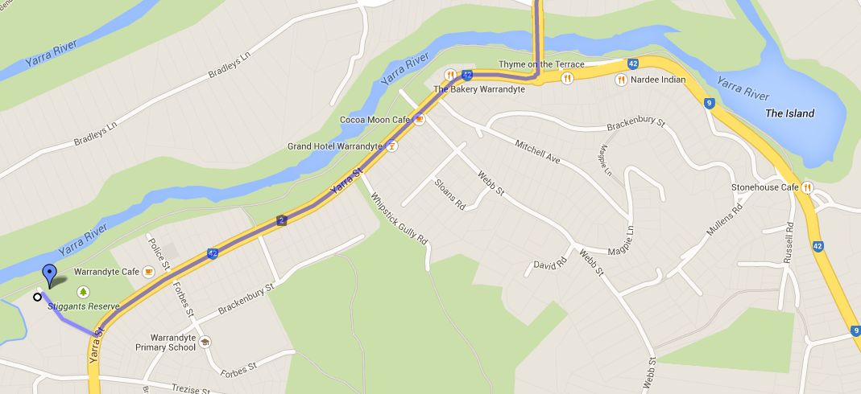

## Meeting Point Map: Main Meeting Point 2, Wallan

*Meet at the blue marker top left – across the road and just past MacDonalds*

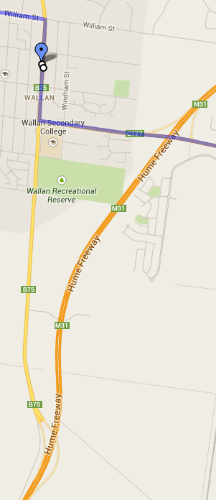

## Summary

|  |  |  |
| --- | --- | --- |
| Warrandyte to Wallan | 61 km | 1 hour |
| Wallan to Hanging Rock | 110 km | 1½ hours |

## Route Instructions

| **km** | **Instruction** | **Notes** |
| --- | --- | --- |
| 1.2 km | **FROM MEETING POINT 1**   1. Go back up the hill and Turn Left onto Warrandyte Road 2. At Roundabout, Turn Left over the Yarra River then immediately go Straight Ahead at the traffic lights |  |
| 6.1 km | 1. At Roundabout, Turn Right onto Eltham-Yarra Glen Road |  |
| 2.9 km | 1. At  sign, Turn Left onto Watery Gully Road, becomes Flat Rock Road |  |
| 4.3 km  250m | 1. At end of road at Give Way sign, Bear Left onto Cherry Tree Road 2. At Roundabout, Turn Right onto Heidelberg-Kinglake Road (C746),signposted to Kinglake |  |
| 2.1 km | 1. Turn Left over bridge onto Cottles Bridge-Strathewen Road, signposted to Arthurs Ck, Strathewen, Whittlesea |  |
| 4.1 km  1.1 km | 1. Turn Left onto Greens Road, small signpost to Whittlesea 2. Turn Right at T intersection onto Hurstbridge-Arthurs Creek Road, signposted to Arthurs Creek & Whittlesea |  |
| 9.8 km | 1. At Roundabout, Turn Right onto Plenty Road (C727), signposted to Whittlesea, and continue to Whittlesea |  |
| 6.1 km | 1. Immediately after school pedestrian traffic lights, Bear Left onto Wallan Road (C727), signposted to Wallan |  |
| 1.8 km | 1. Turn Left onto Clarks Road (at the end of a double row of pine trees, unless they’ve been cut down!) |  |
| 4.2 km | 1. At Roundabout, Bear Left to continue on Glenburnie Road |  |
| 1.6 km | 1. At Roundabout, Turn Left onto Janna Road |  |
| 2.0 km | 1. At T intersection, Turn Right onto Merriang Road / Epping-Kilmore Road (C729), signposted to Wandong | Care: entering main road |
| 8.4 km | 1. Turn Left onto Wallan-Whittlesea Road (C727), signposted unsurprisingly to Wallan. Cross over Melbourne-Sydney Railway line, straight ahead at Roundabout, cross over Hume Freeway. |  |
| 3.9 km  400m | 1. At Traffic Lights, Turn Right onto Northern Highway (B75), distantly signposted to Kilmore 2. Pull into Woolworths Carpark on the left, opposite and just after MacDonalds |  |
| 600m | **FROM MEETING POINT 2:**   1. Head North along Northern Hwy 2. At traffic lights, Turn Left onto William St, signposted to the unpronounceable Darraweit Gulm & Romsey |  |
| 27.2 km | 1. In Romsey, at the main crossroads and Give Way sign, Turn Right onto Melbourne‑Lancefield Rd | *Regroup just entering Romsey if necessary* |
| 10.4 km | 1. Go through Lancefield, cross a creek on Musteys Bridge, then Turn Left onto Burke & Wills Track signposted to Baynton, Wineries & Lancefield Golf Club | Yes, *that* Burke & Wills |
| 24.3 km  1.1 km | 1. Just after the bitumen narrows to a single lane, where there’s a white water tank on the right, Turn Left onto Watchbox Road (unsignposted) 2. At T intersection with Give Way sign, Turn Left to continue on Watchbox Road | *Measure this distance!* |
| 9.8 km | 1. At T intersection with *lots* of Stop signs, Turn Left onto Heathcote-Kyneton Road (C326) |  |
| 14.9 km | 1. Turn Left onto Pipers Creek Road, signposted to Baynton, Sidonia & Pyalong | If you reach the M79 freeway, you’ve missed the turnoff! |
| 1.9 km | 1. Turn Right onto Batters Lane (should be 2nd on the right) | It has a X roads sign |
| 1.6 km | 1. Turn Left onto Trio Road, becomes Cobb and Co Road |  |
| 9.3 km | 1. At Roundabout, Take the 1st Exit onto Anderson Road, signposted to Lancefield (if the trees aren’t obscuring the sign) |  |
| 5.6 km | 1. At T intersection, Turn Right onto Rochford Road (C324), signposted to Hanging Rock |  |
| 1.8 km | 1. Turn Left (***before*** the T intersection!) onto South Rock Road (C322), signposted to Hanging Rock |  |
| 1.3 km | 1. Turn Left into Hanging Rock park |  |

## Route Map

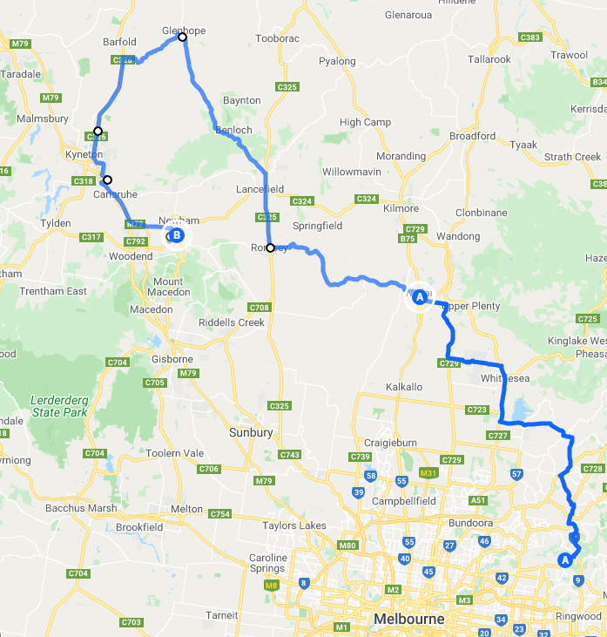

## HANGING ROCK

<https://www.visitmacedonranges.com/tourism-listing/hanging-rock/>

